**Chest CT Segmentation Guide**

The chest CT segmentation app was created using the MATLAB app designer tool. This application provides the user with a friendly interface to segment chest CT scan images and create a completely new series a Unique Identifier(uid). Unique Identifiers are a series of numbers unique to each set of medical imaging data in DICOM format.

*Note:* *The Chest CT Segmentation app is exclusively created for segmentation of medical images in DICOM format (.dcm extension). The program works best with axial scans.*

**Axial Chest CT scan example:**

*Image obtained from* [*https://radiologykey.com/cardiac-anatomy-using-ct/*](https://radiologykey.com/cardiac-anatomy-using-ct/)

**Program Purpose**

Oftentimes during a 3D reconstruction process, the presence of unwanted anatomical features can decrease the efficiency of automatic thresholding and significantly increase the amount of manual segmentation required. While most programs do allow for a rectangular/circular crop, unwanted regions around the object of interest may remain and interfere with the efficiency of the overall 3D reconstruction.

The chest CT segmentation app gives the user the liberty to remove all unwanted regions prior to uploading the scans to a 3D reconstruction program. An example of the final product after using this application is shown below:

**Application UI**

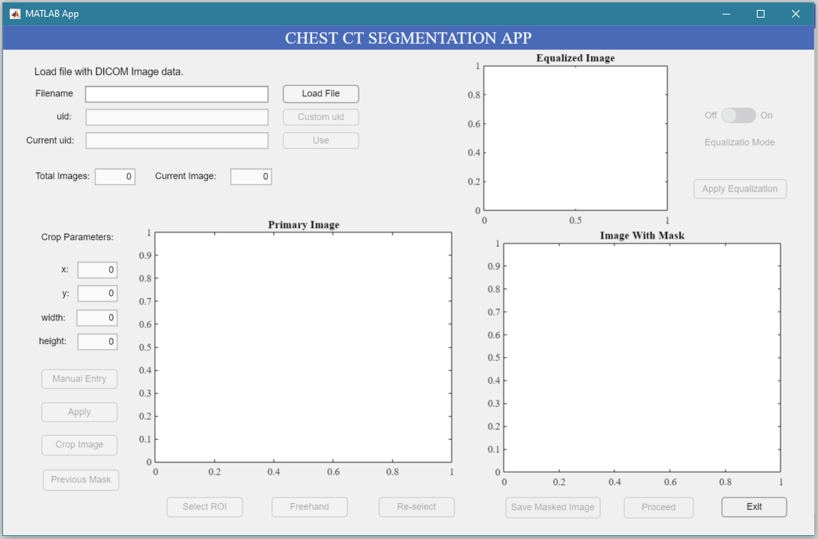The application exhibits a simple interface with self-explanatory features designed to guide the user through a seamless segmentation experience. **To install the app, open MATLAB first and then click on the application file. On being asked whether you want to install the file, click ‘install’. The application will appear under ‘APPS’.**

1. **Applying Histogram Equalization**
2. **Loading Your Images**
3. **Cropping**
4. **Selecting Region of Interest (ROI)**
5. **Applying Binary Mask**
6. **Using Previous Mask**
7. **Loading Your Images**
8. To load your images, simply enter the filename and press the ‘Load File’ button if the file is in the same folder as your MATLAB interface.
9. If your files are in a different location, enter the file path instead.
10. Note: You DICOM series of images MUST be placed in a folder and the same folder name must be used to load your files.

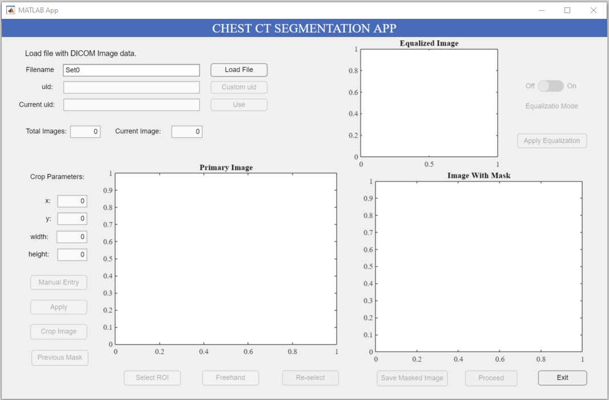

***Enter filename and click ‘Load File’.***

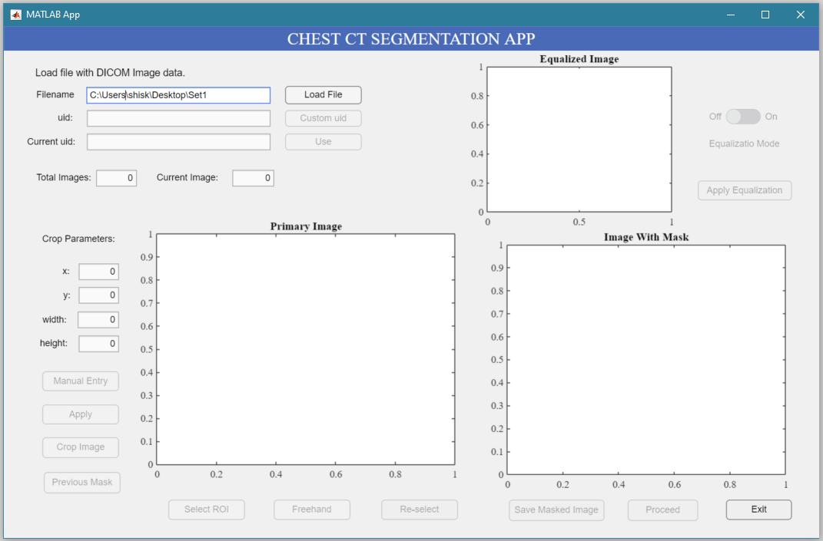

***Enter file path and click ‘Load File’.***

1. After loading a file, you can either use the series uid created by the program or enter a custom uid.
2. *Note: Every time you load a new folder, the images get associated with a newly created uid.*
3. Using custom uid allows you to write images as a part of the same series. This can be useful while working with file containing a large number of pictures as segmenting all images in one sitting may be unfeasible.

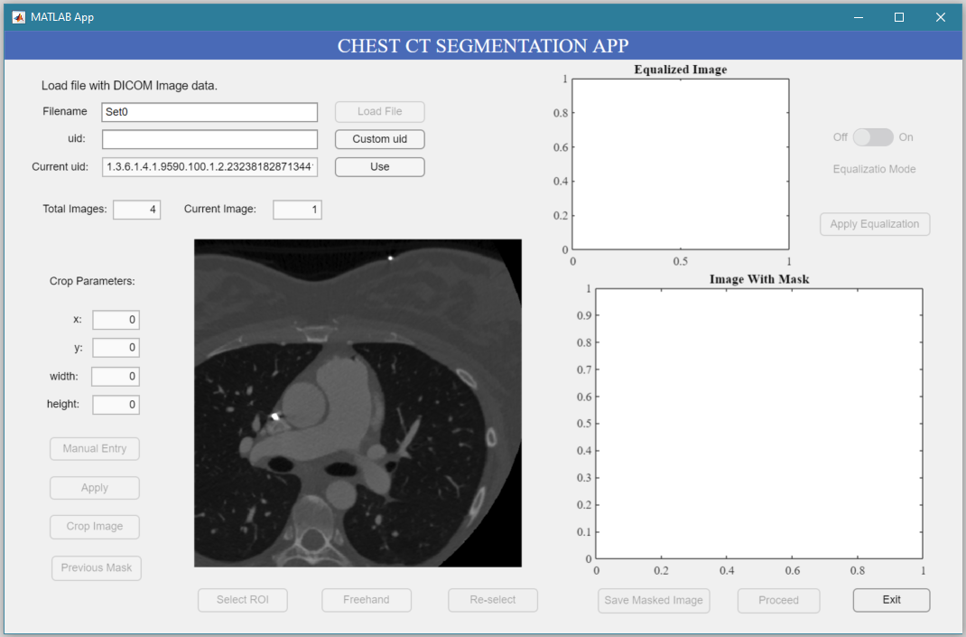

***Current image***

***Total number of images in the file.***

***You can use uid created by the program.***

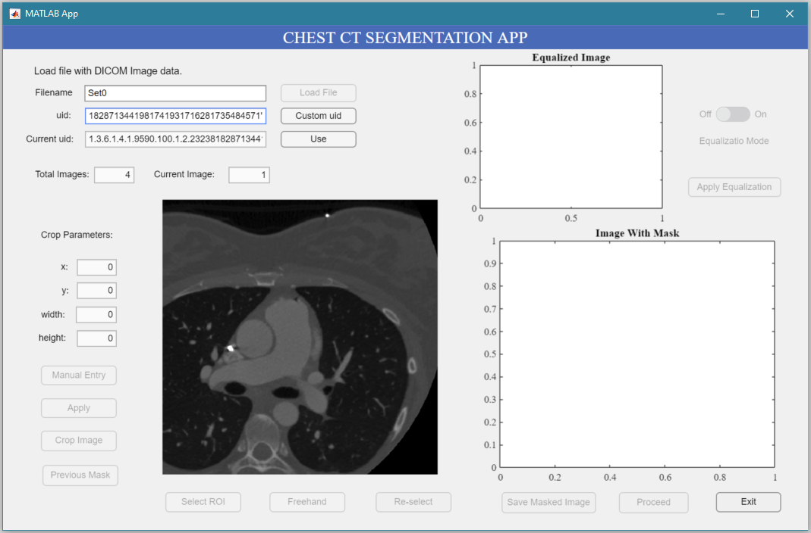

***Or enter your custom uid.***

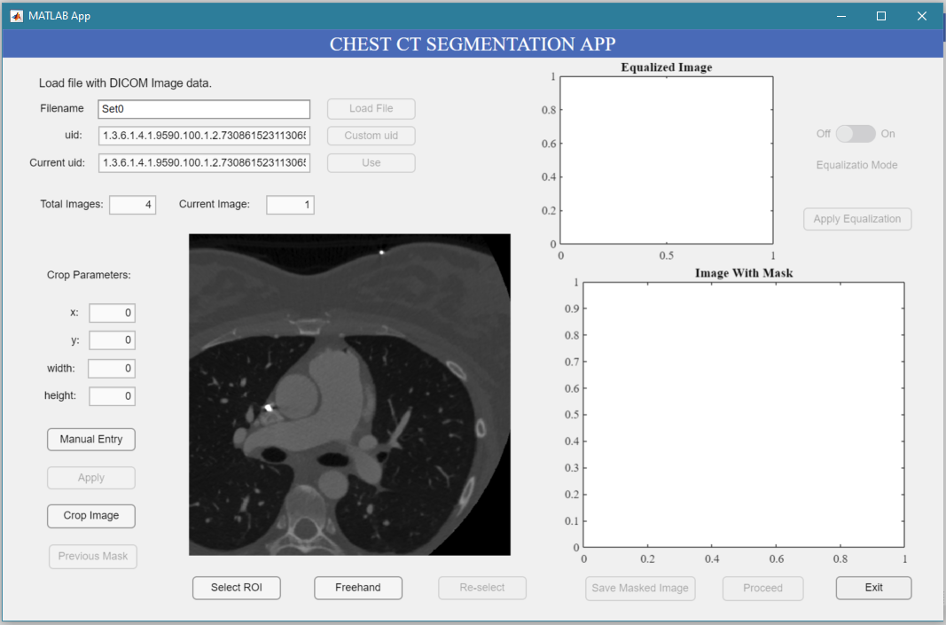

***If you choose to enter your custom uid, The current uid will be updated to match your uid.***

1. **Cropping**

Cropping the images to get rid of black regions towards the boundary can be beneficial especially in cases of images in which histogram equalization must be done for accurate edge detection.

1. To create a rectangular crop on the image, click ‘Manual Entry’ and enter coordinate points (x, y, width, height) of the rectangle. After entering all four values, click ‘Apply’.



1. ***Click ’Manual Entry’.***
2. ***Click ‘Apply’.***
3. ***Enter values.***

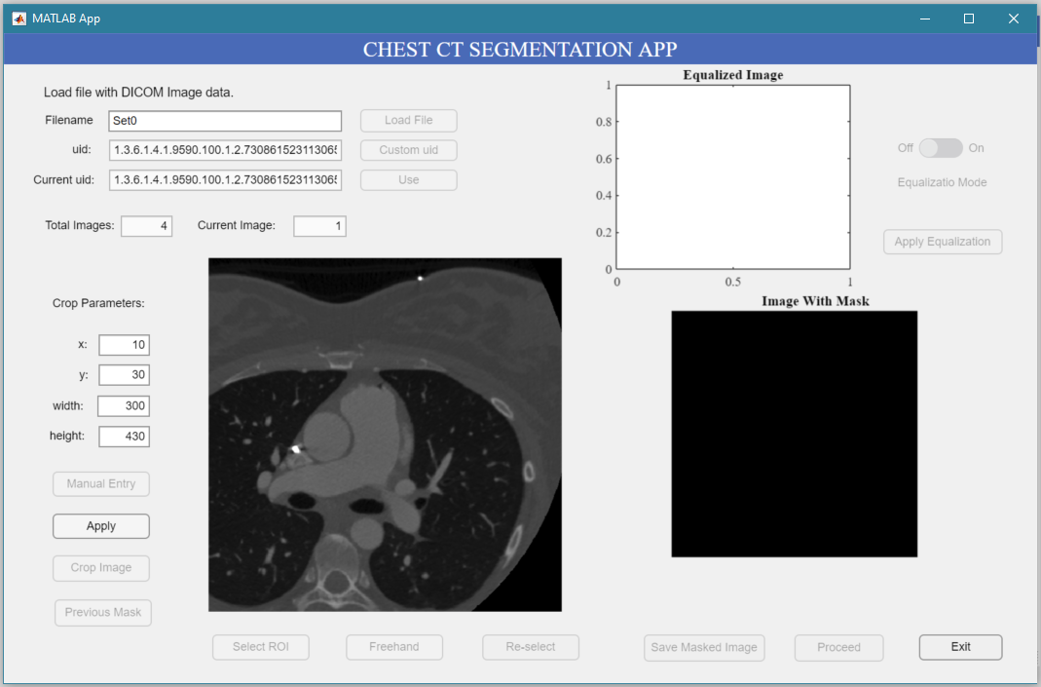

1. 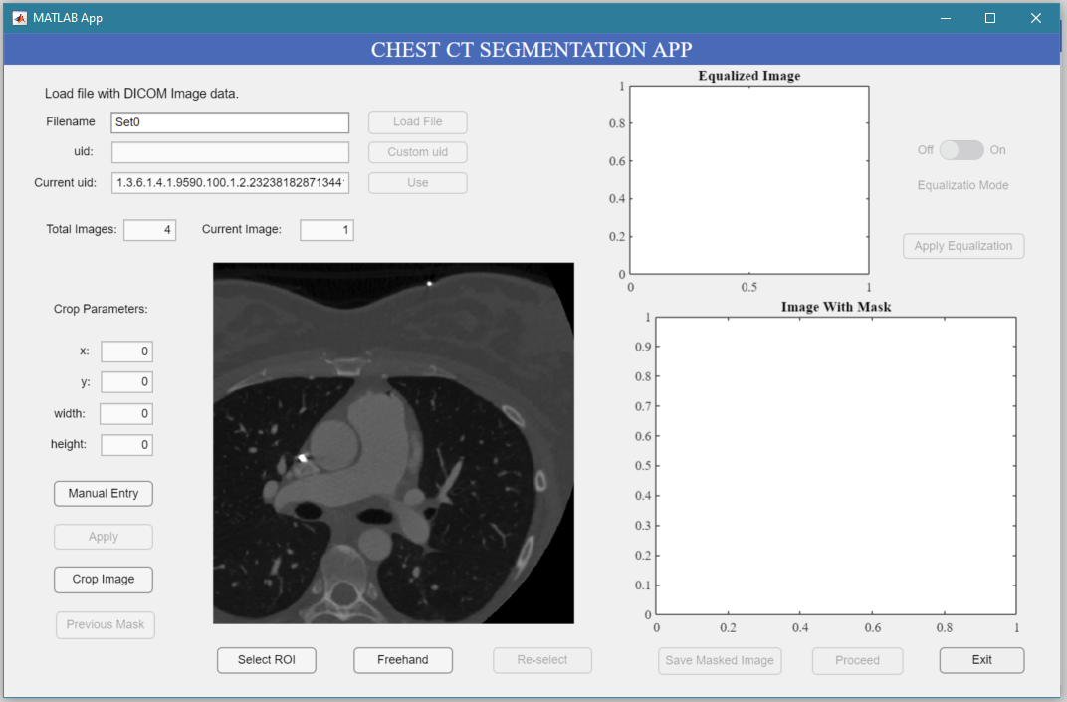You can also crop by clicking ‘Crop Image’ and drawing a rectangular region directly on top of the image.
2. ***Click ‘Crop Image’.***

1. ***Draw rectangular region.***
2. *Note: Click ‘Manual Entry’ or ‘Crop Image’ to reset the image and start cropping again.*
3. **Selecting Region of Interest (ROI)**
4. After cropping, click ‘Select ROI’ to draw a circular region of interest on top of the image.

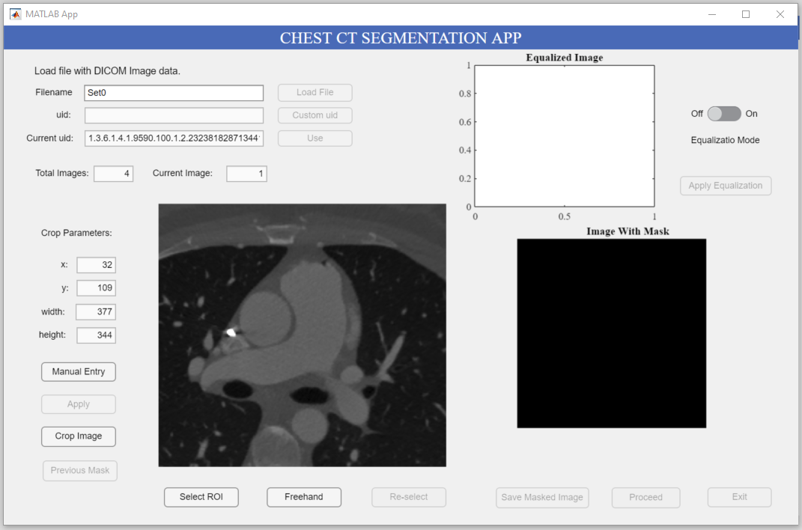

1. ***Click ‘Select ROI’.***
2. Graphical user interface, application, PowerPoint

   Description automatically generatedThe circular ROI drawn will behave as a starting boundary for active contours edge detection algorithm. Region inside the circular ROI will be saved and everything outside the ROI will be eliminated.
3. ***Draw circular ROI.***
4. Click ‘Re-select’ to remove the previous ROI and draw a new one.

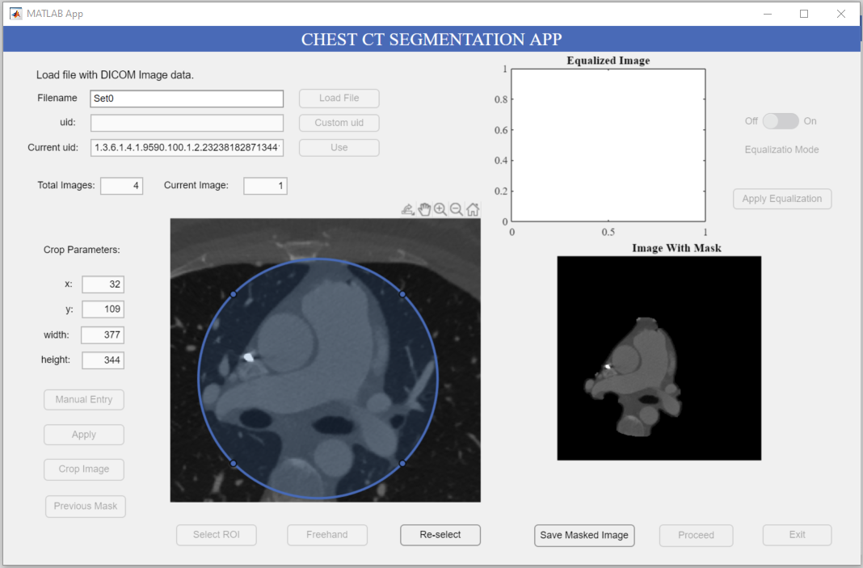

1. **Apply Binary Mask**
2. Once the circular ROI has been drawn, the isolated image will appear under ‘Image with Mask’. Click ‘Save masked Image’ to save this image.
3. Click ‘Proceed’ to move to the next image or “Exit’ to close the program.

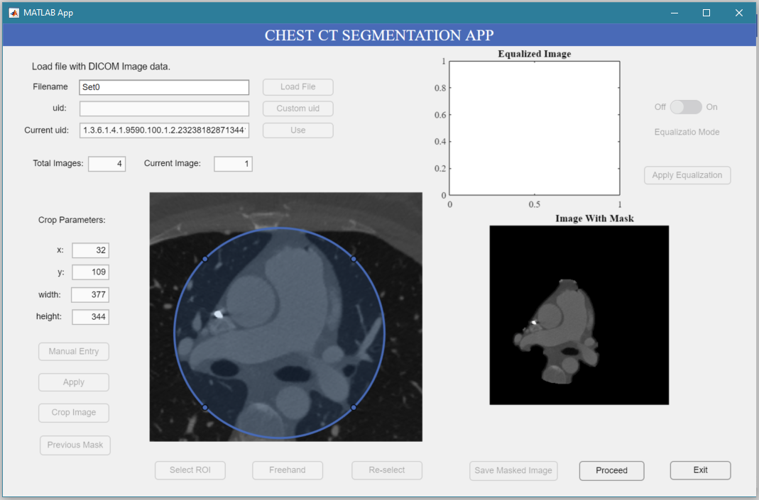

***‘Proceed’ and ‘Exit’ will be enabled after you click on ‘Apply Mask’.***

1. ***Click ‘Save Masked Image’.***
2. **Histogram Equalization**

Applying histogram equalization can increase efficiency of edge detection in some scenarios where the boundary of an object cannot be distinguished easily.

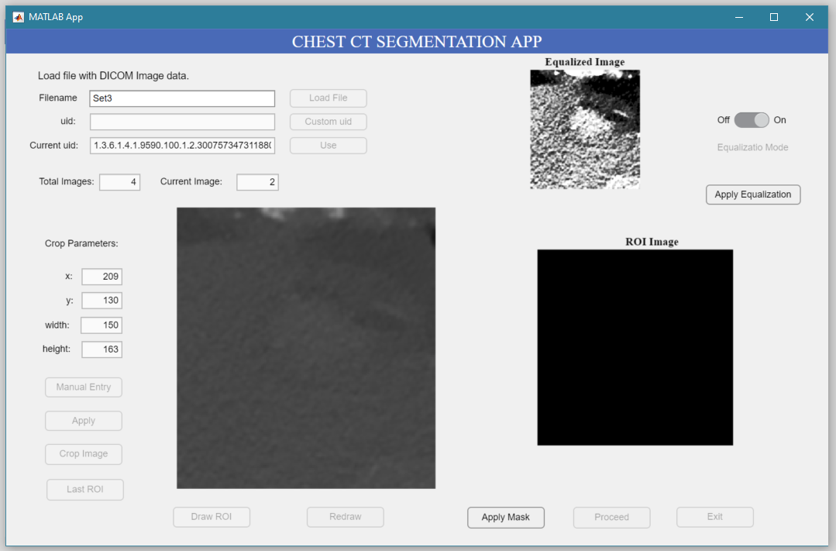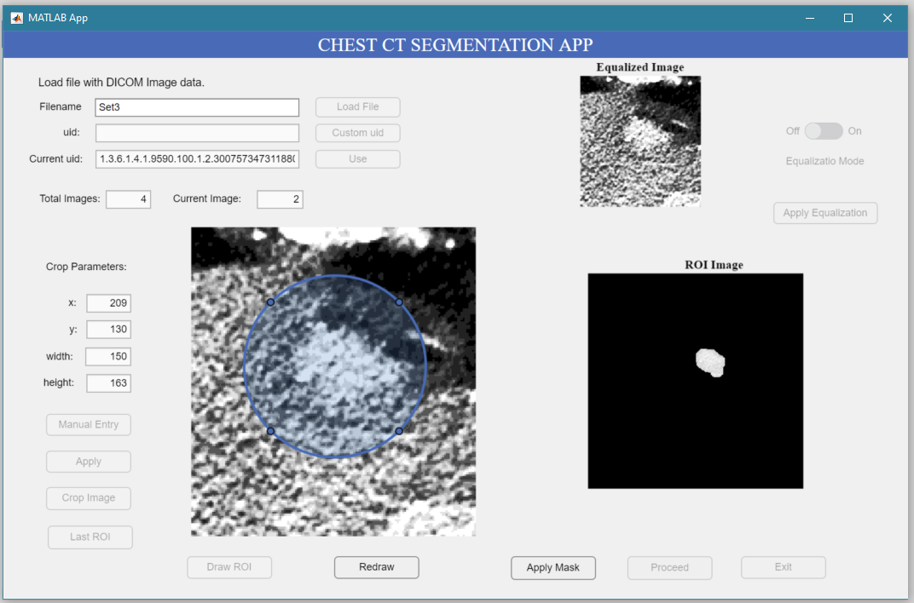

**Before Equalization After Equalization**

1. The histogram equalization switch will be enabled after the image has been cropped.

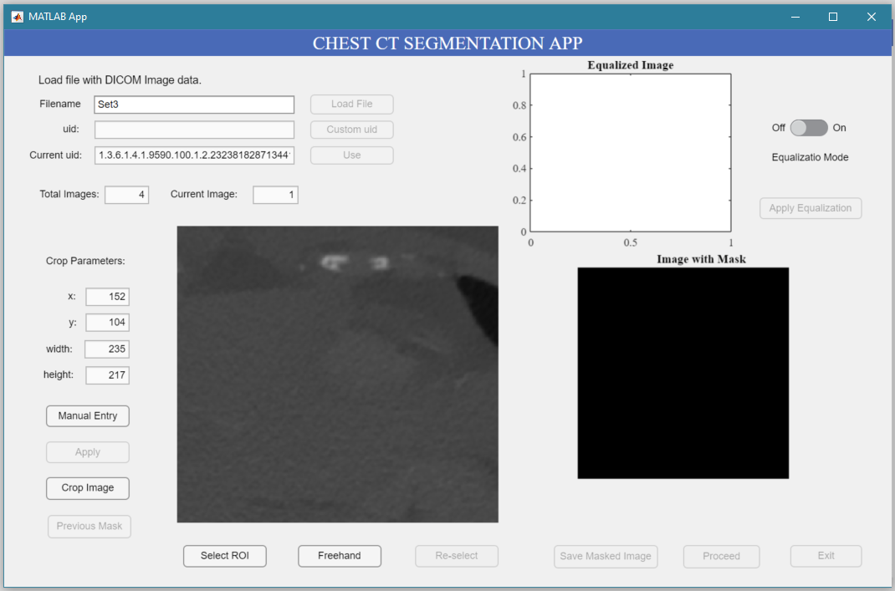

***Turn on “Equalization Mode’ to view equalized image.***

1. The equalized image can be seen under ‘Equalized Image’.
2. Click ‘Apply Equalization’ to use equalized image.

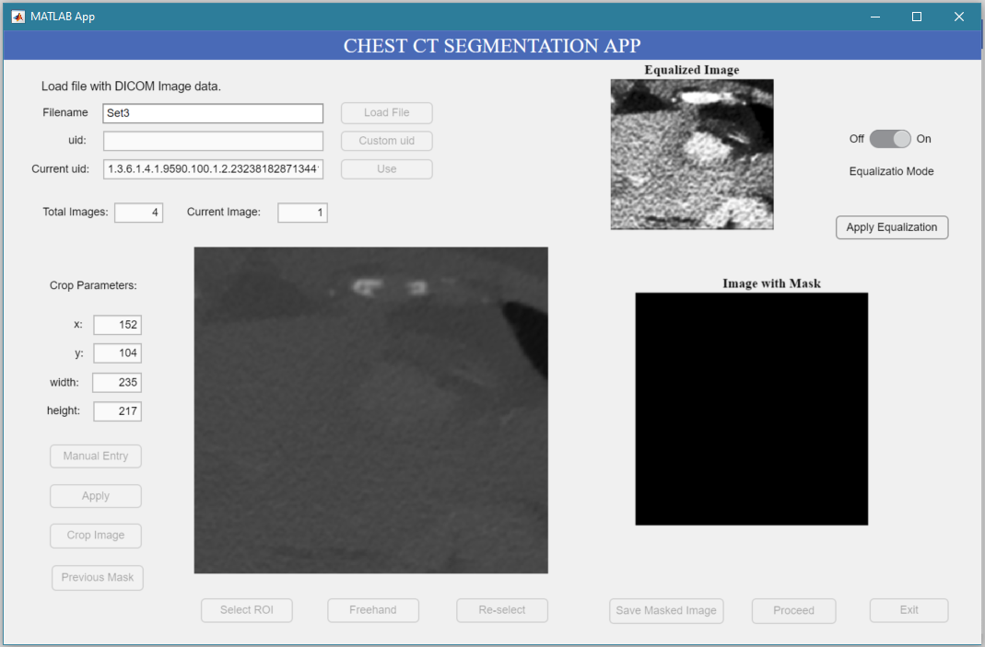

***Click ‘Apply Equalization’.***

1. Click ‘Select ROI’ to draw circular region of interest.

***Click ‘Select ROI’.***

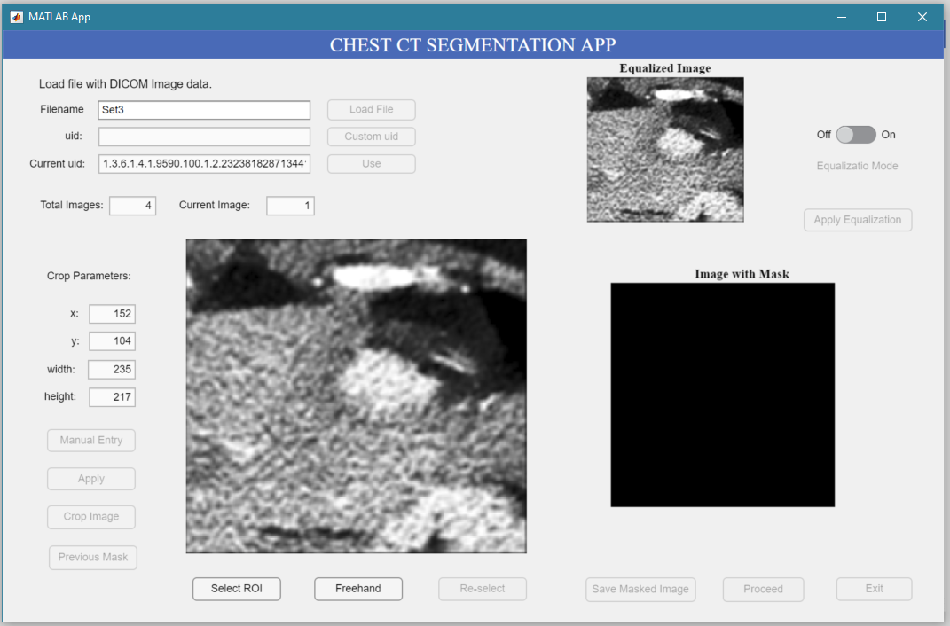

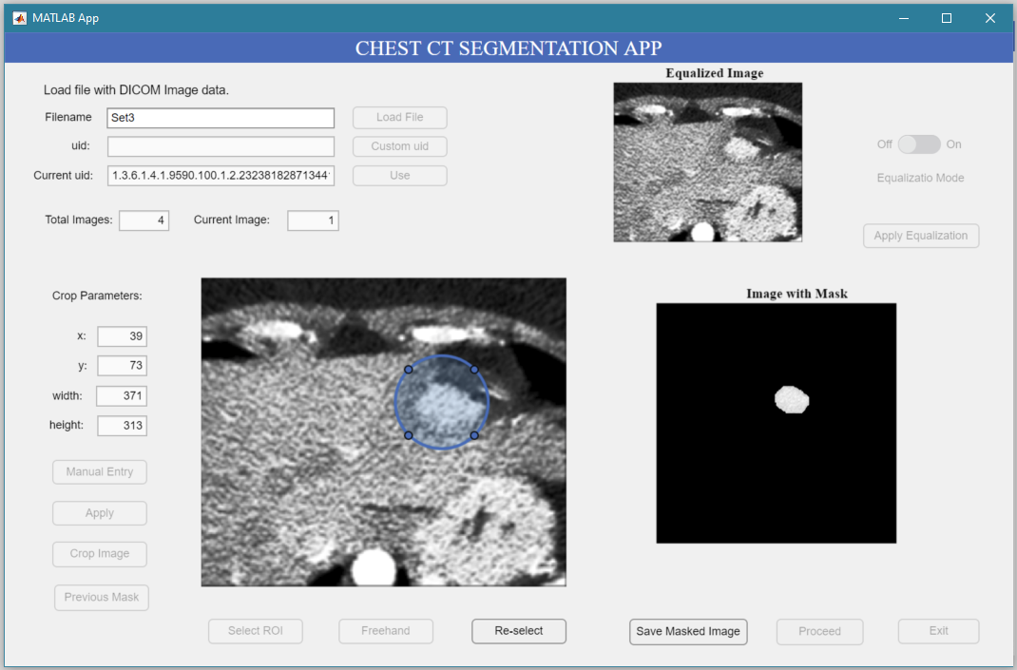

***Isolated region of interest.***

1. **Using Previous Mask**

The ‘Last ROI’ button can be used to apply the last binary mask to the current image. This can be useful during medical image segmentation as consecutive images tend to have very similar or same regions of interest.

1. After clicking ‘Proceed’ the program will load the next image. Click ‘previous Mask’ to directly obtain the segmented image without having to crop or draw circular ROI.

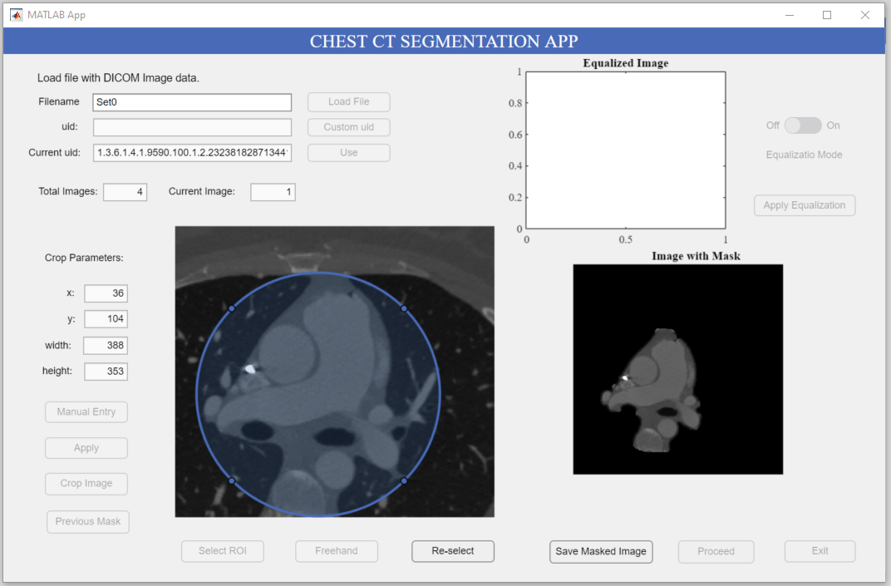

1. ***Segment the first (or any image after) manually.***
2. ***Click ‘Last ROI’ to use previous mask for this image.***

***3. Click ‘Proceed’.***

***2. Click ‘Save masked Image’.***

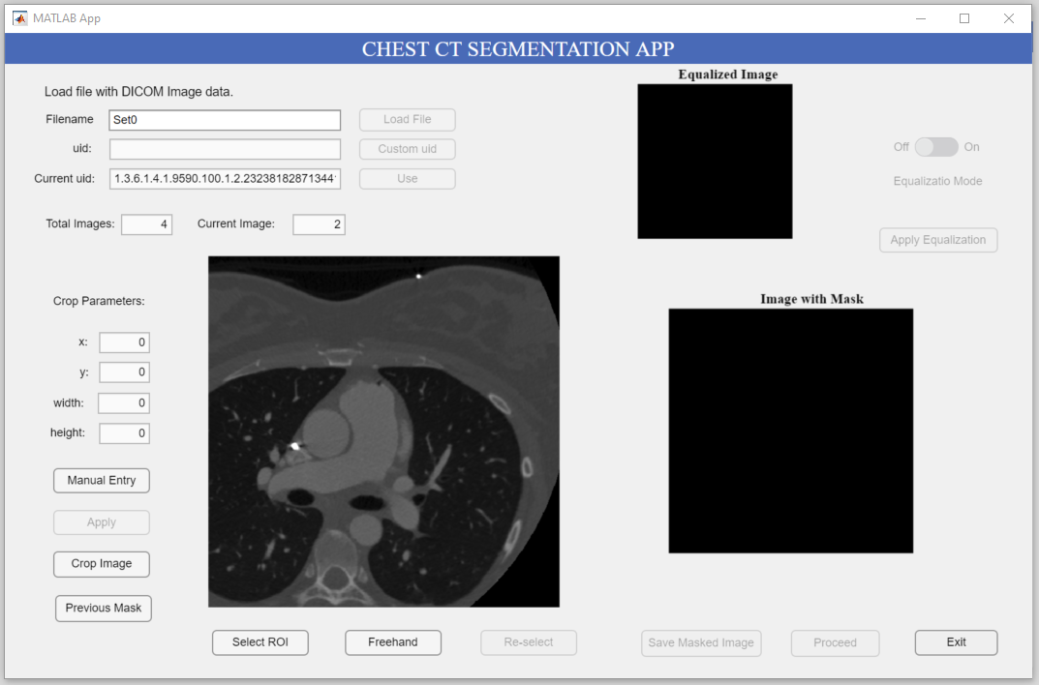

***4. Click ‘Previous Mask’.***

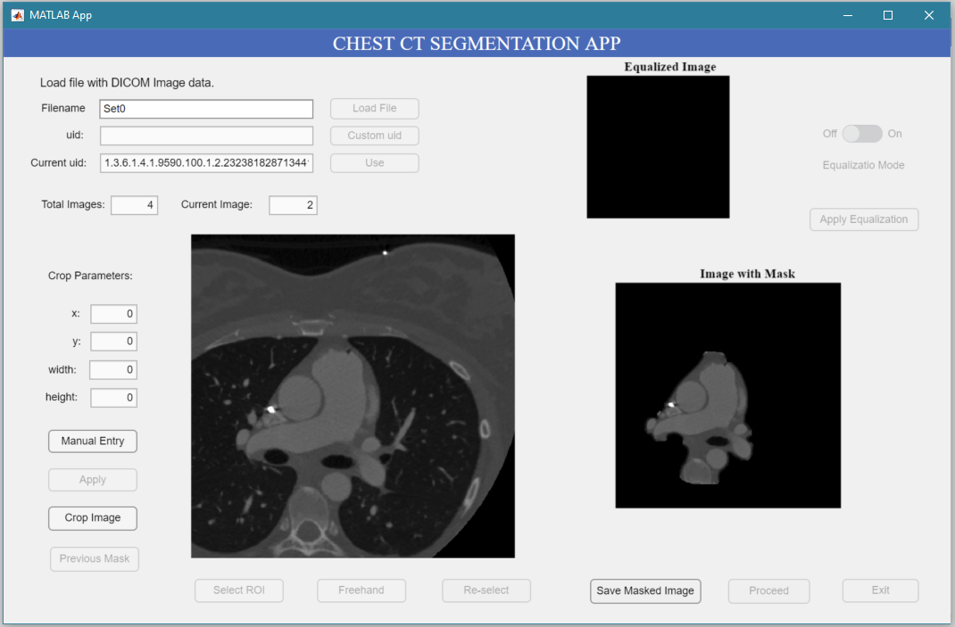

***Binary mask from last image applied to current image.***

1. After all the images have been segmented, the user will be prompted to exit.

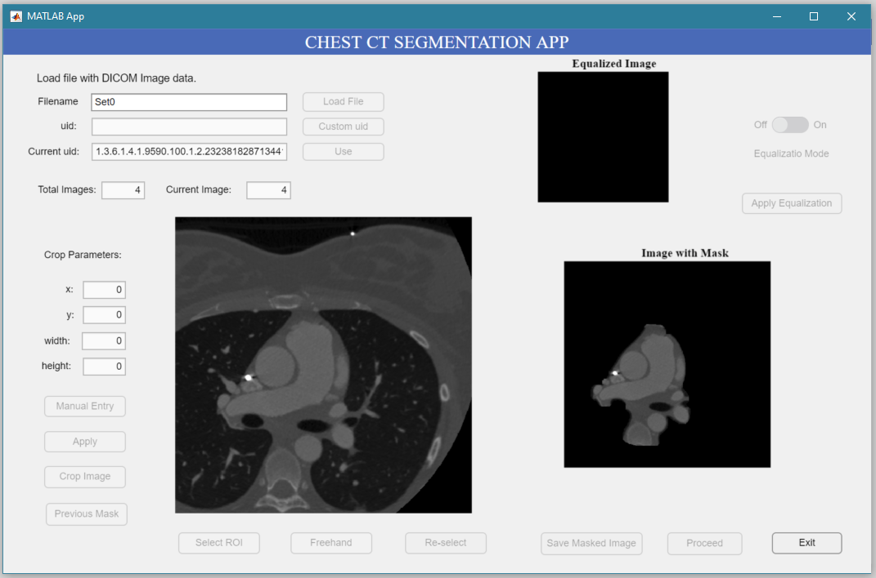

***Click ‘Exit’ to close the program.***

**Added functionality as of 2/10/21**

1. **Using Freehand**

The freehand option allows the user to draw any ROI on the image freely.

1. To begin drawing, crop the image and click on ‘Freehand’.

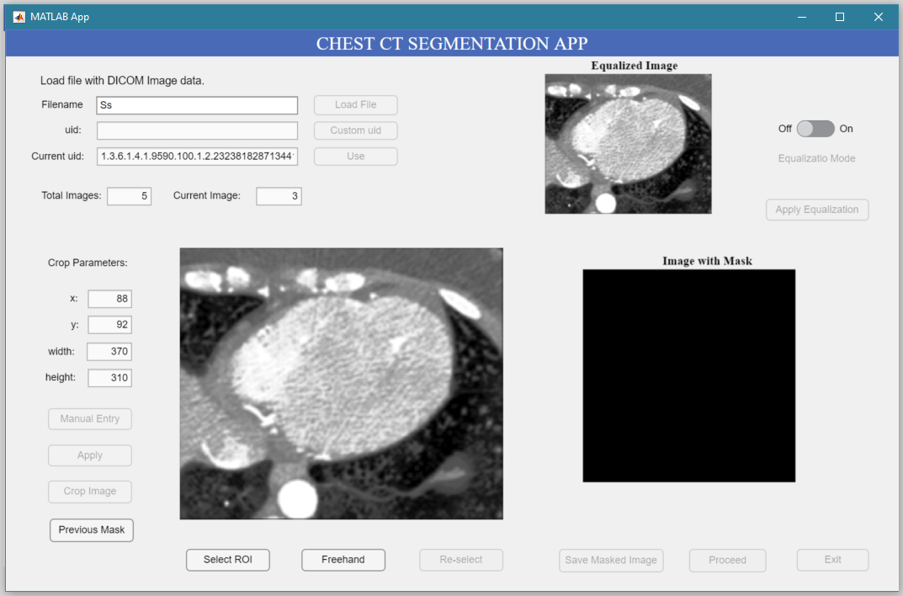

1. ***Click to start drawing.***
2. Hover your mouse pointer on top of the image until a ‘+’ cursor appears and start drawing.

***2. Finish drawing around region of Interest with your mouse.***

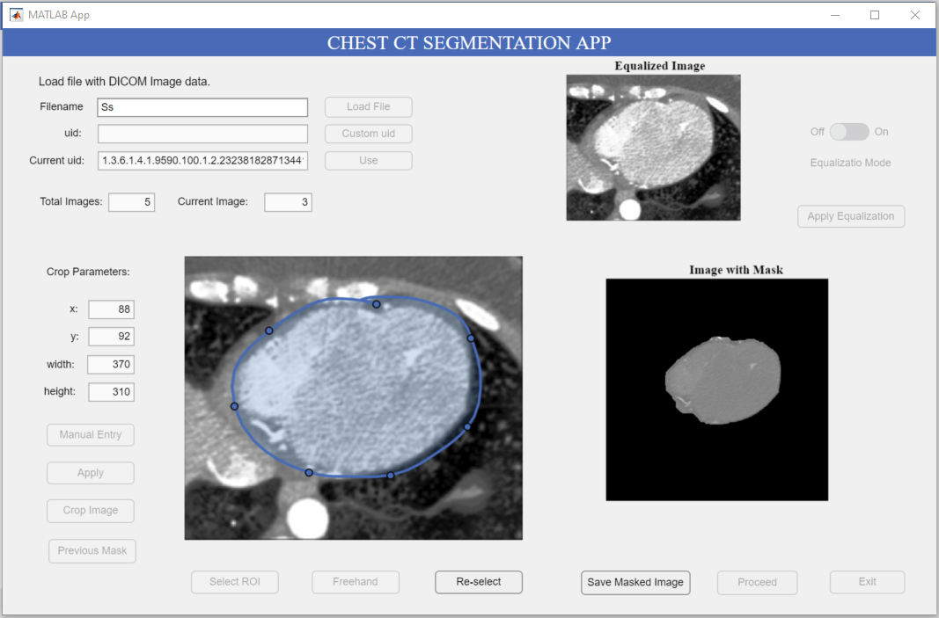

***4. Click ‘Save Masked Image’ to save the result or ‘Re-select’ to reset drawing options.***

***3. Release mouse to see the result.***